**Week 4**

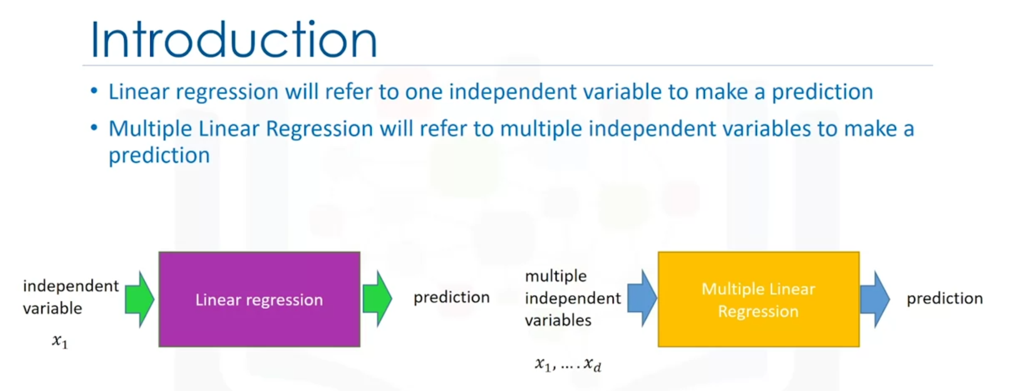

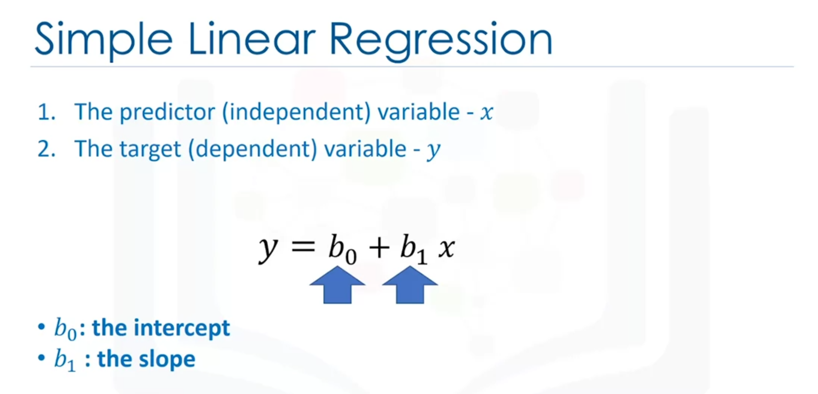



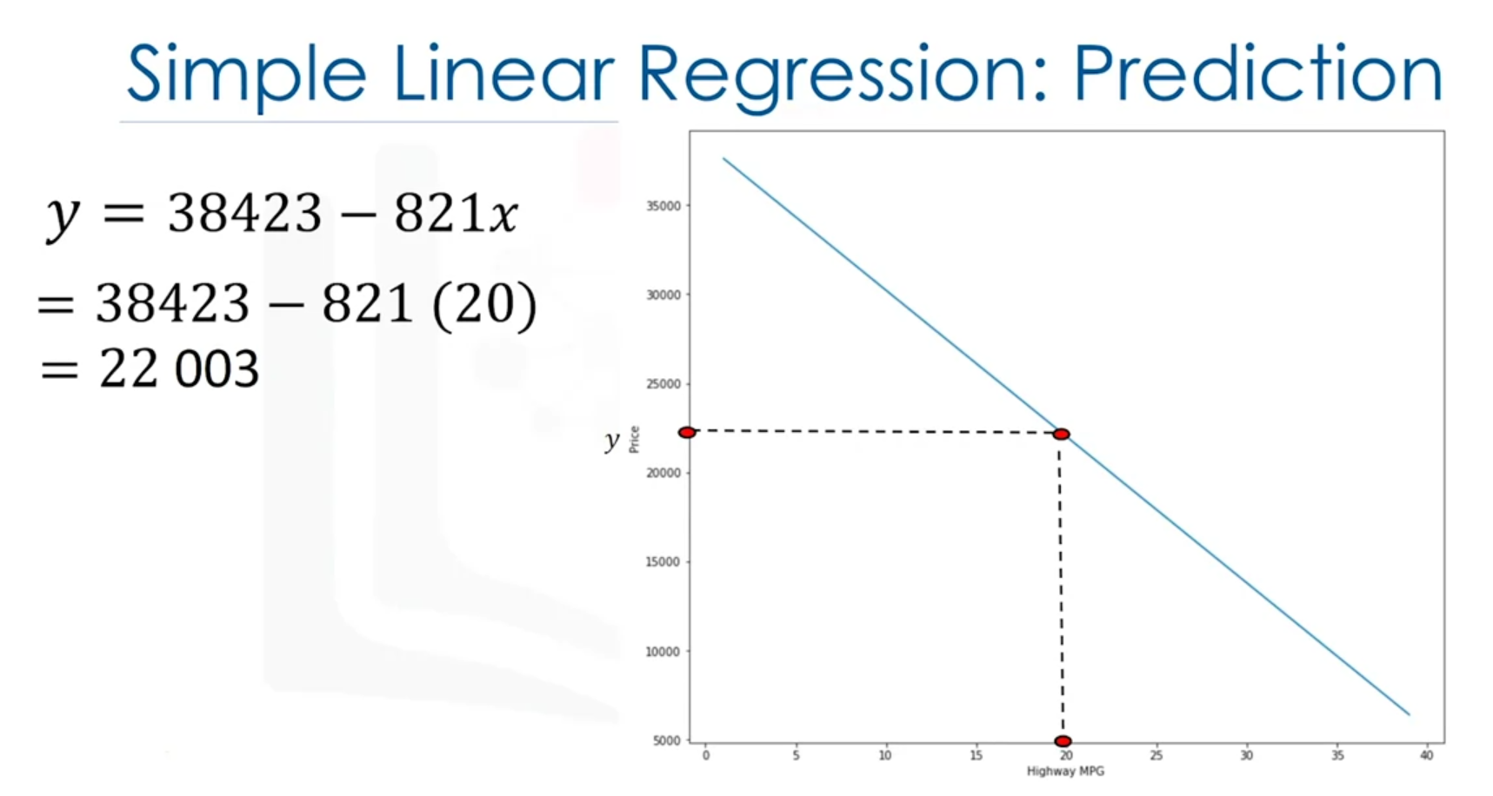

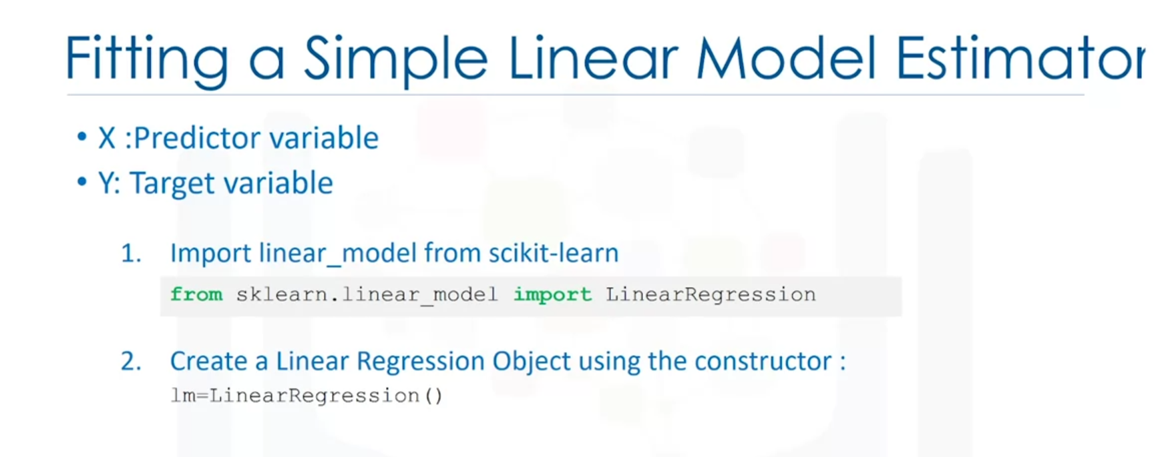

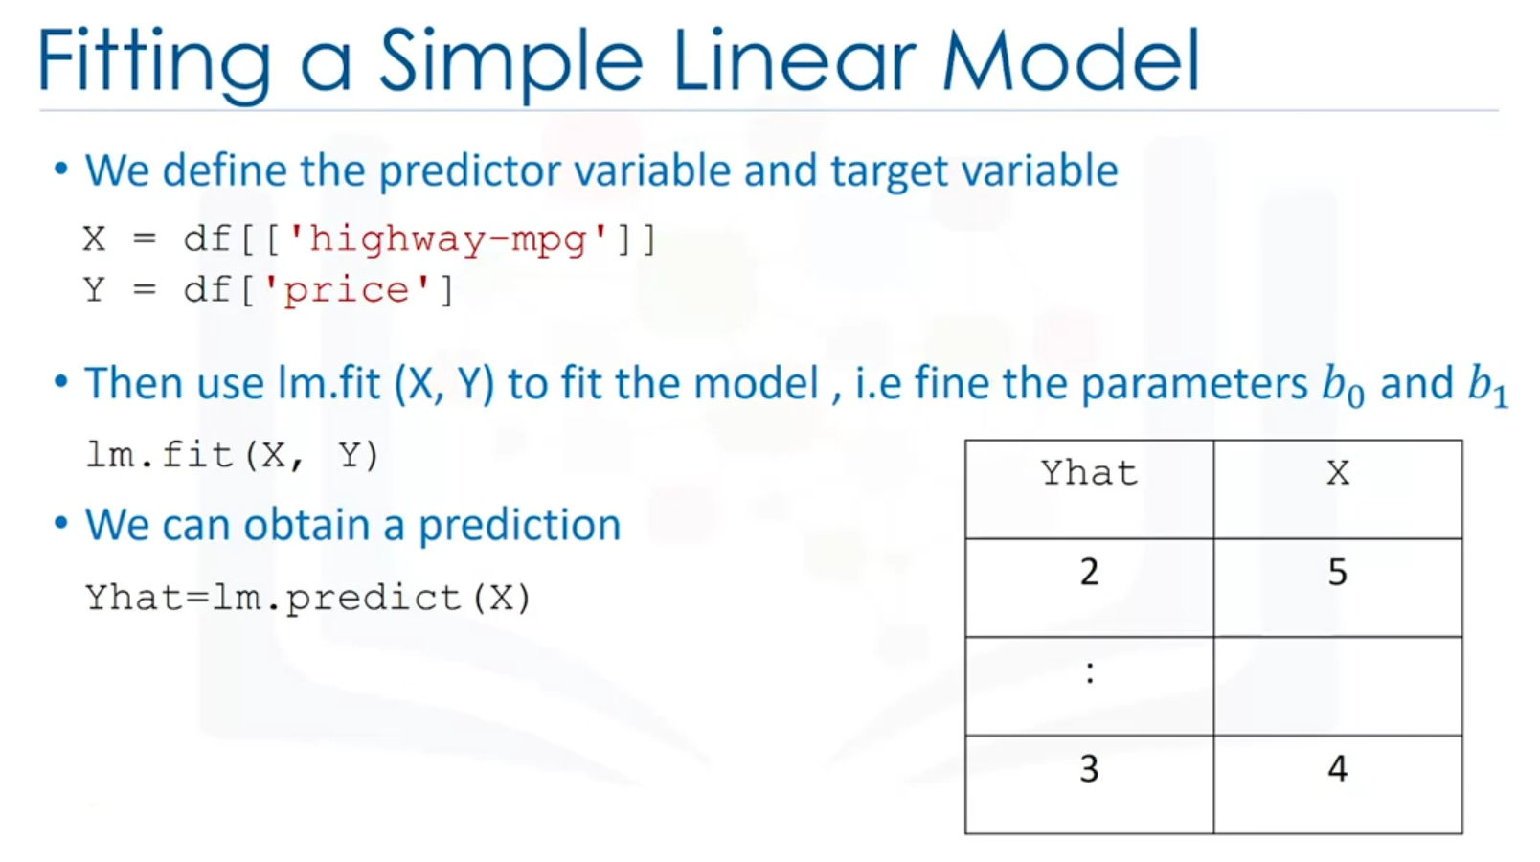

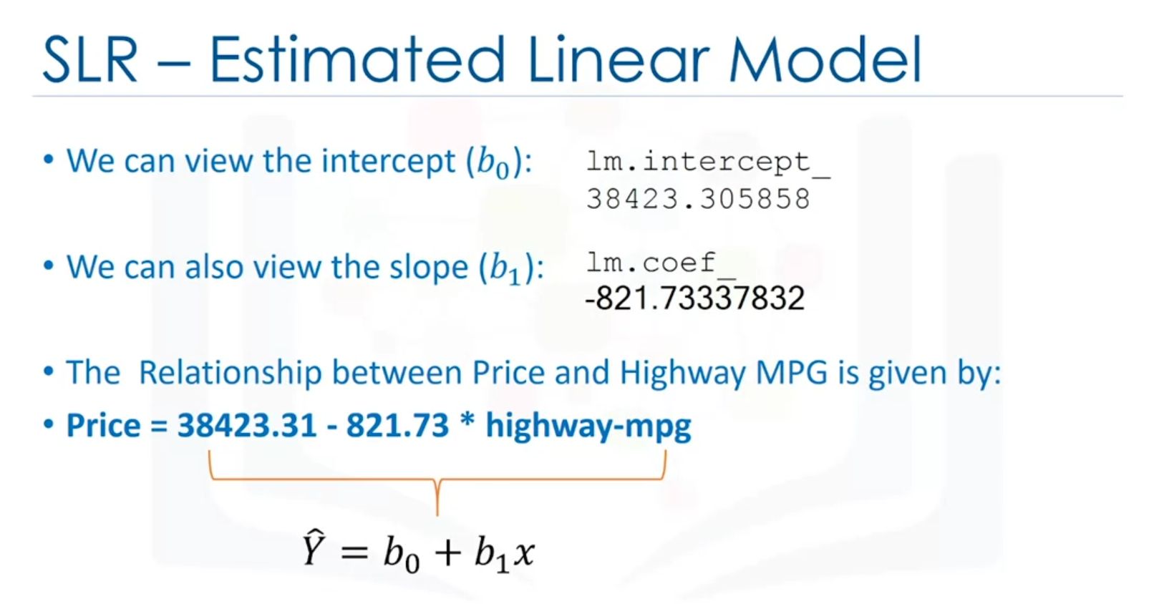

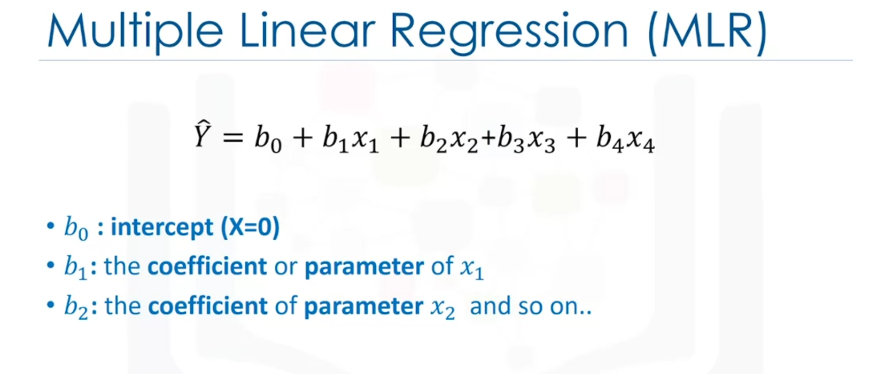

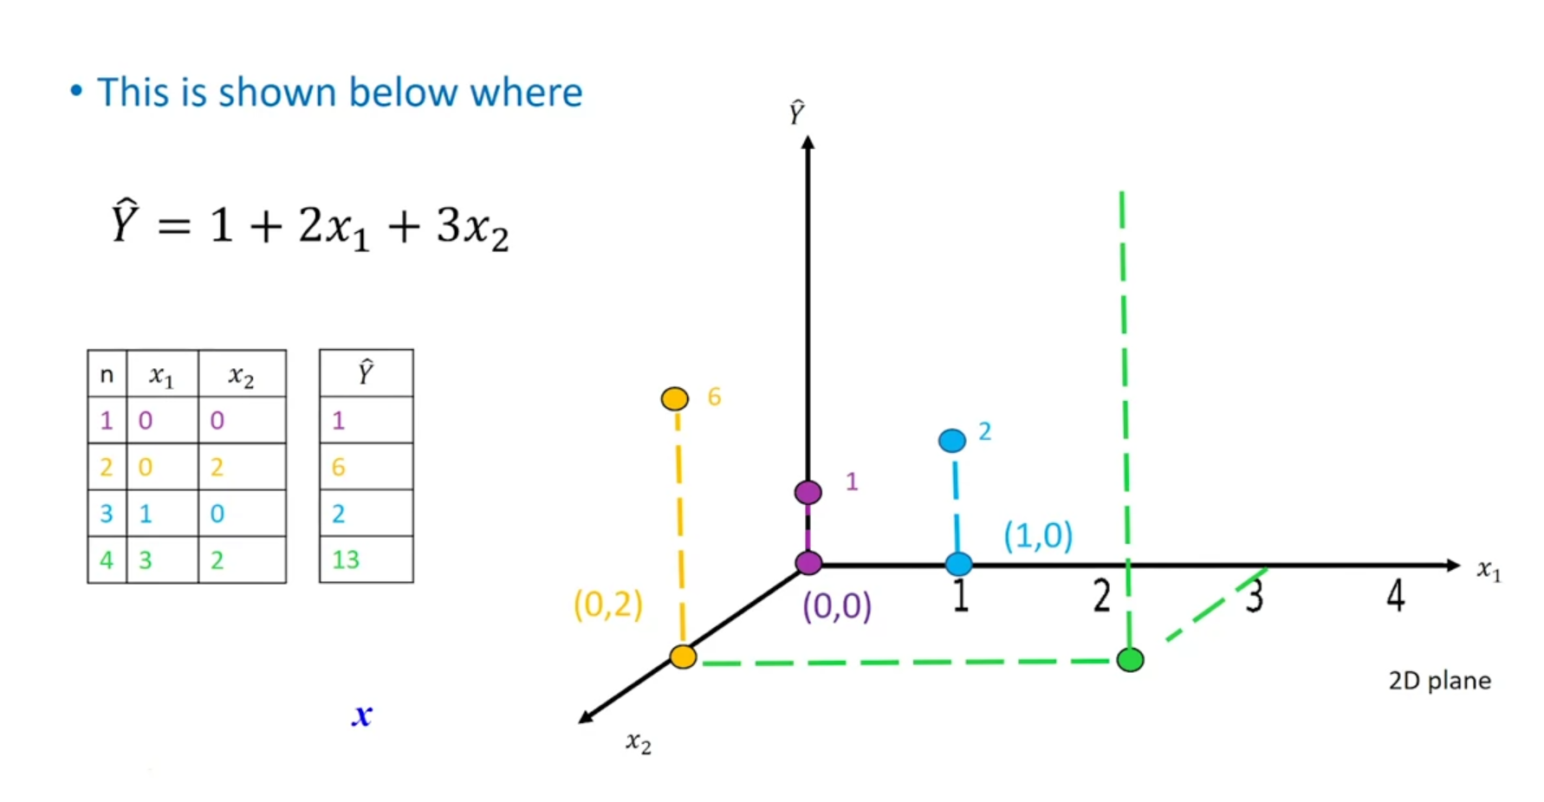

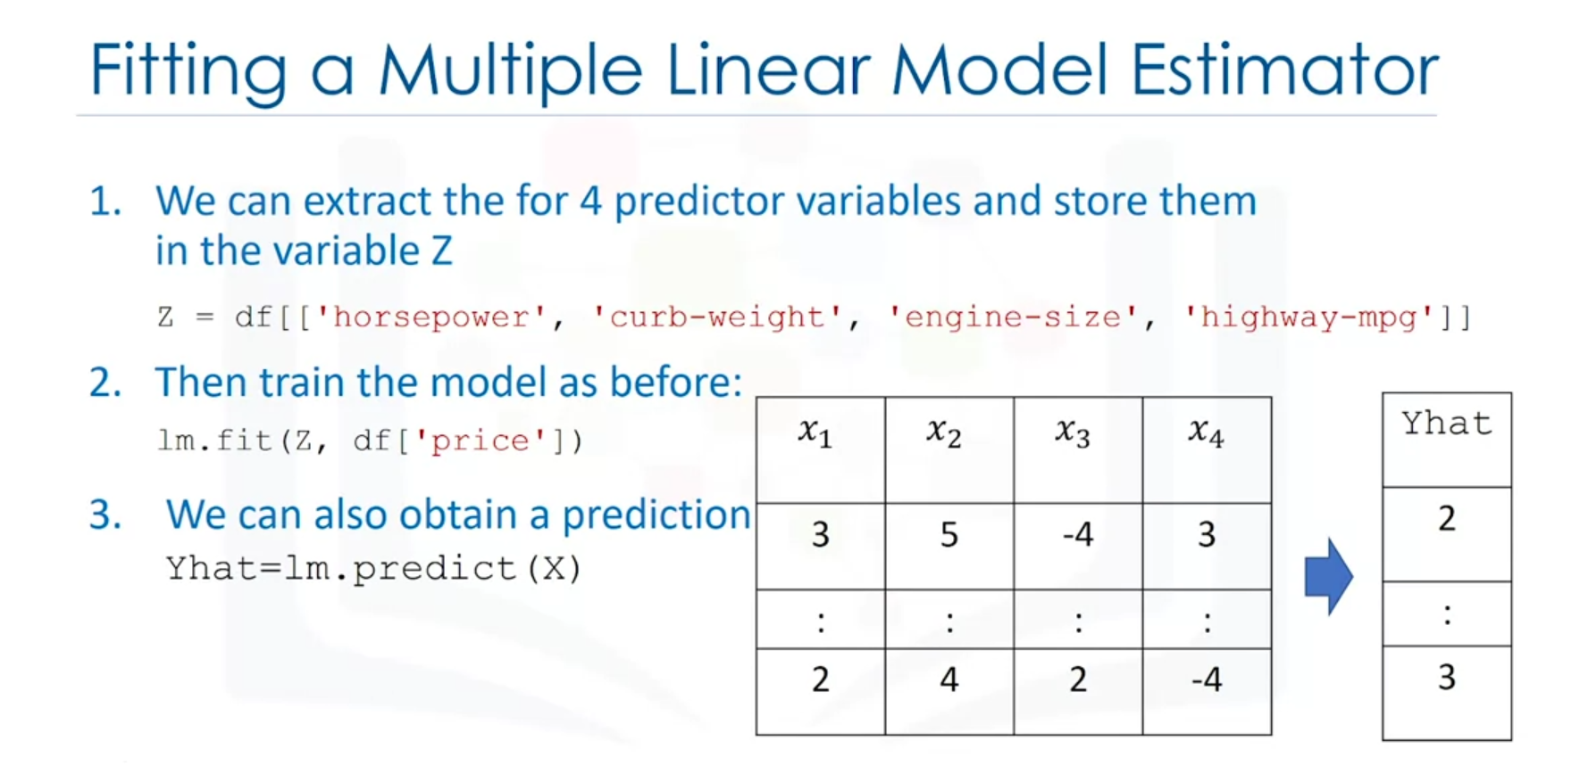

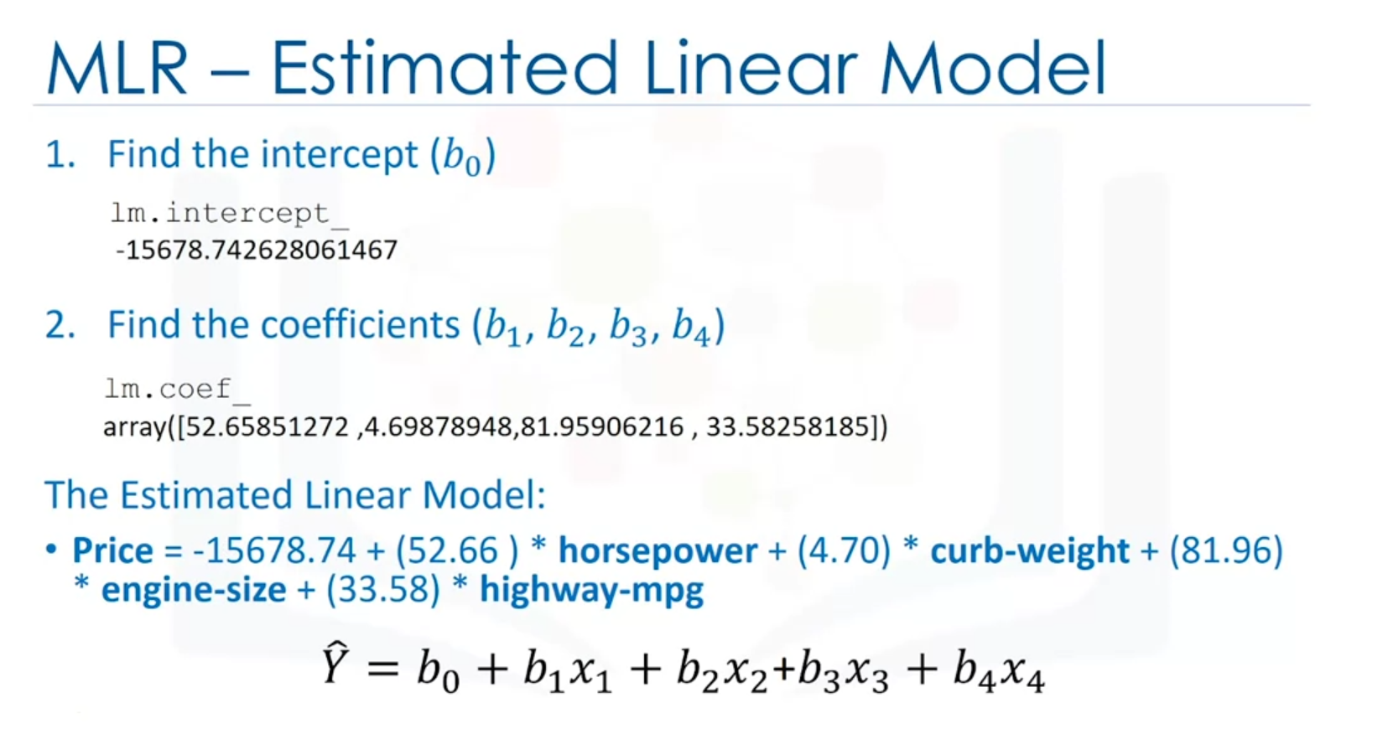

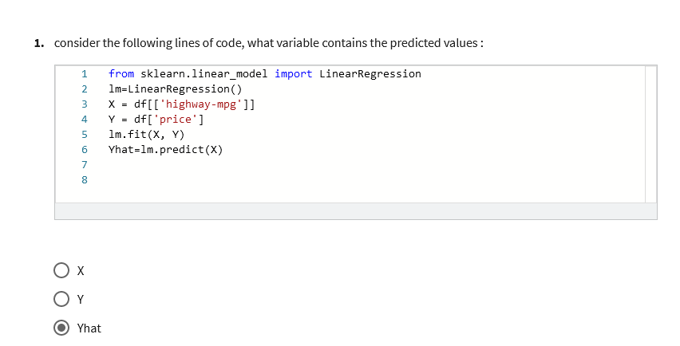

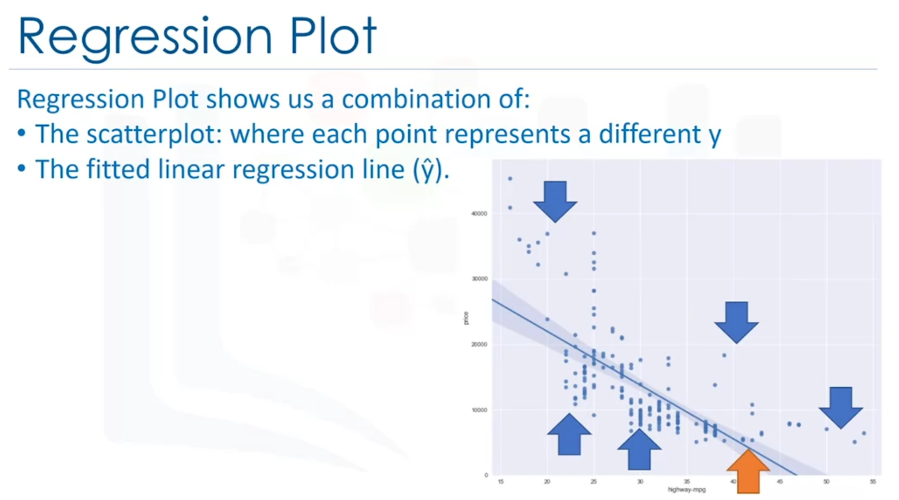

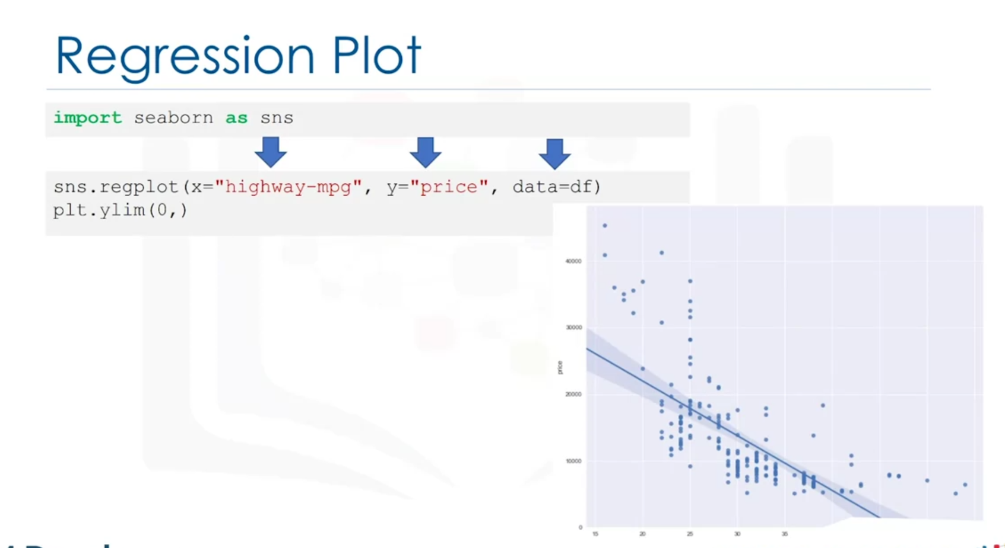

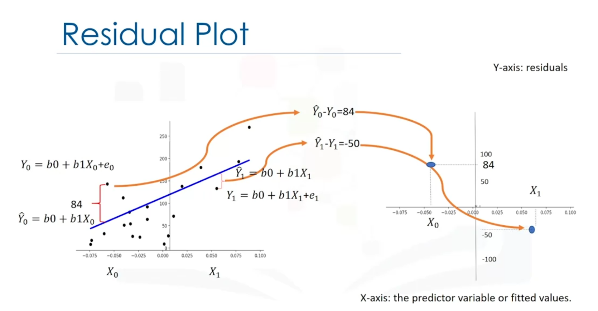

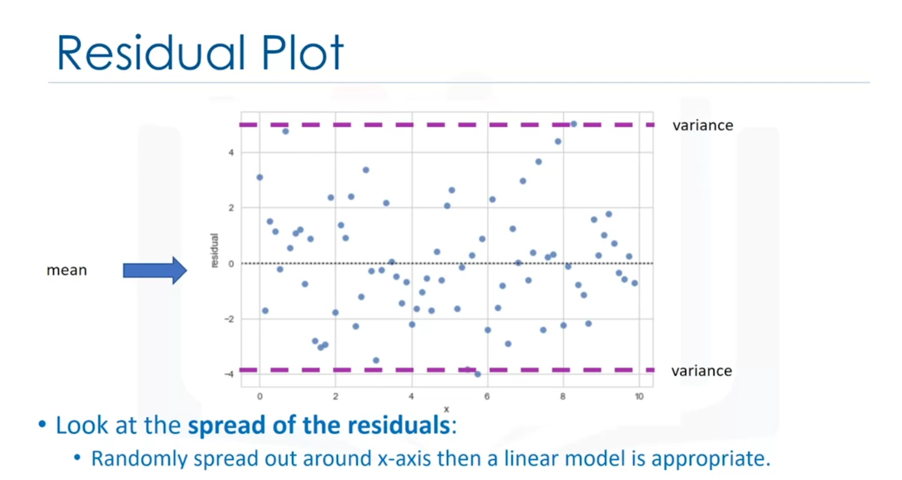

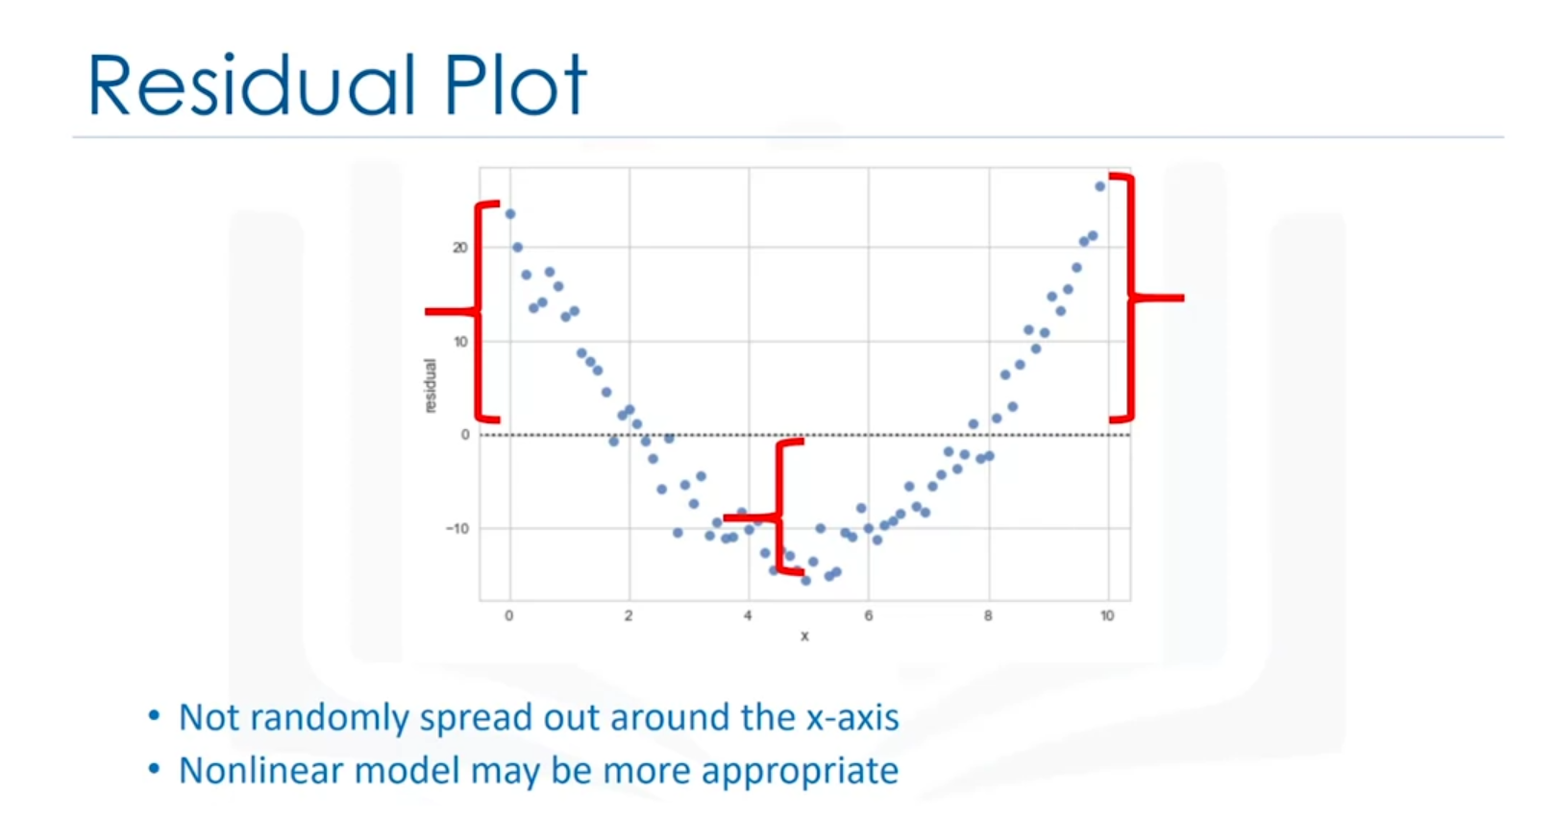

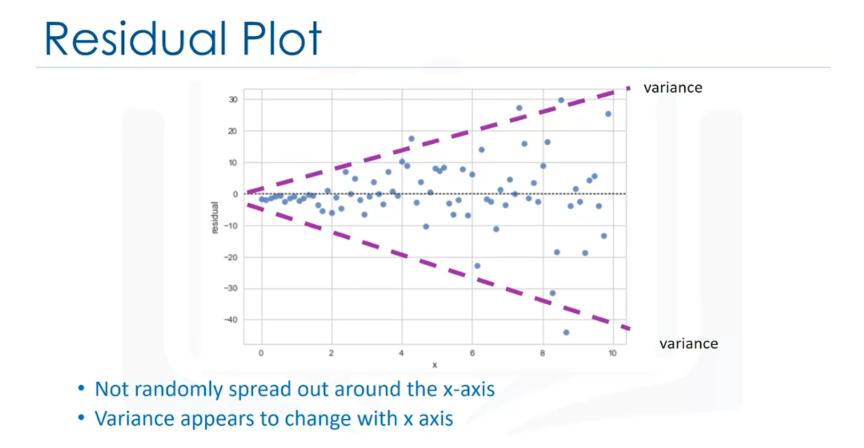

Model incorrect.

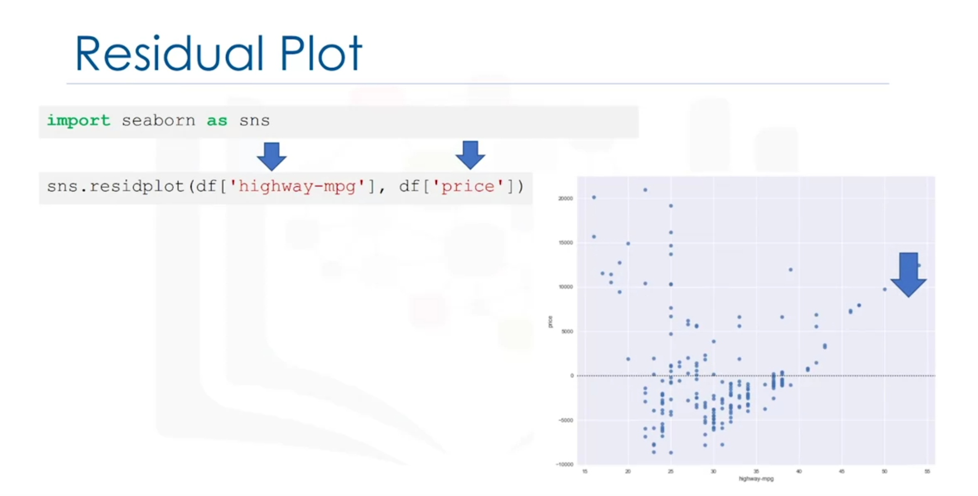

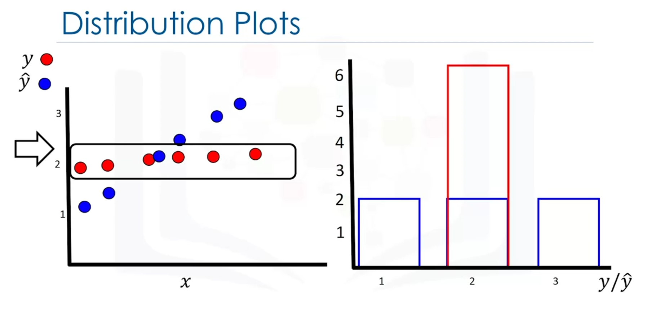

Y = actual values (?) and y hat = predictor values (?).

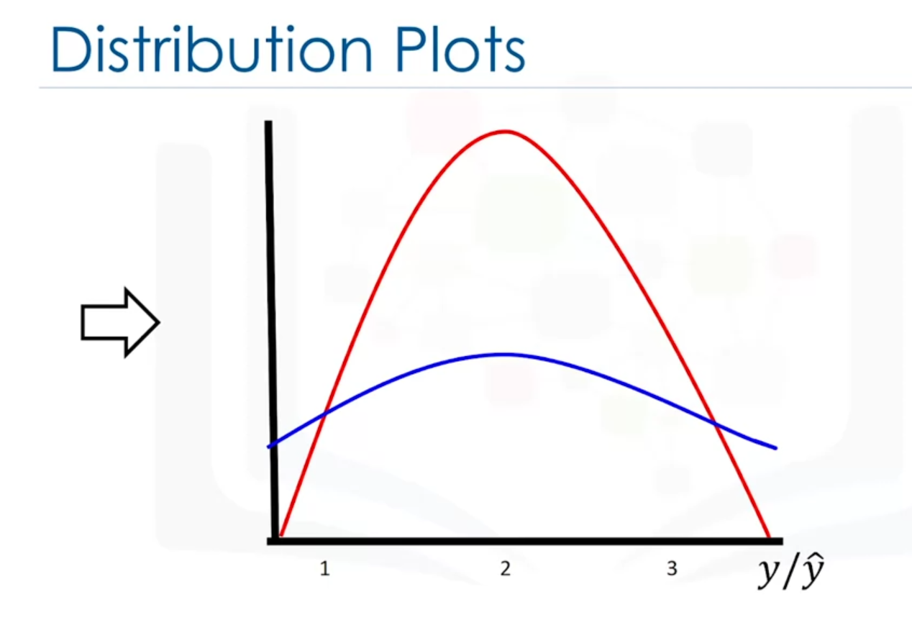

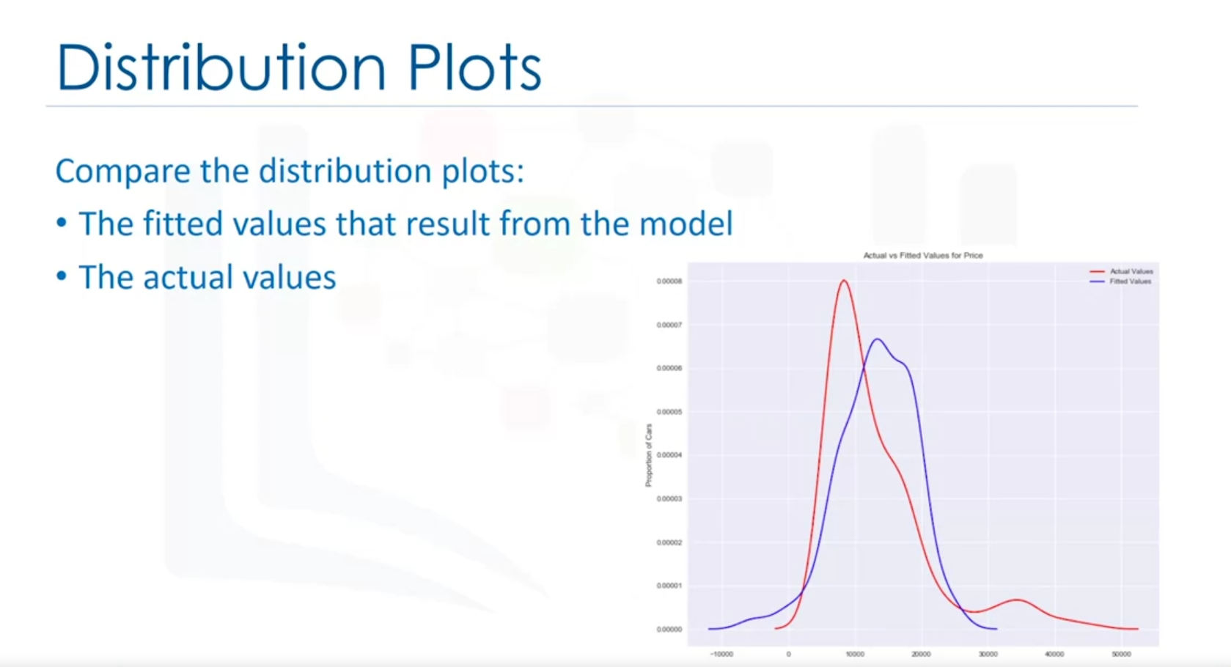

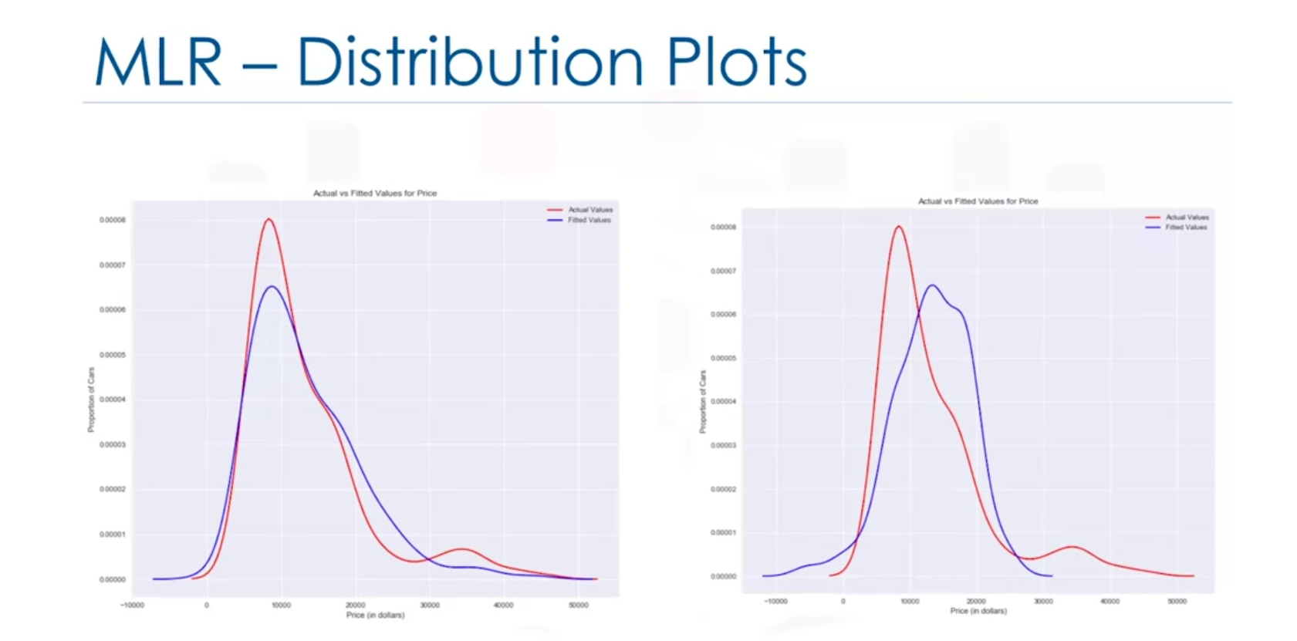

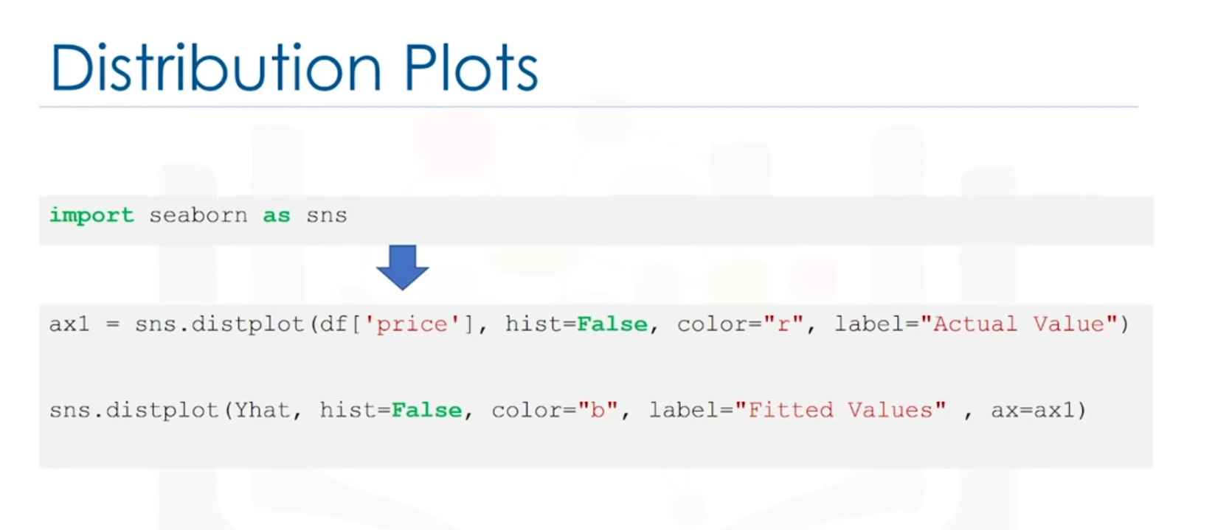

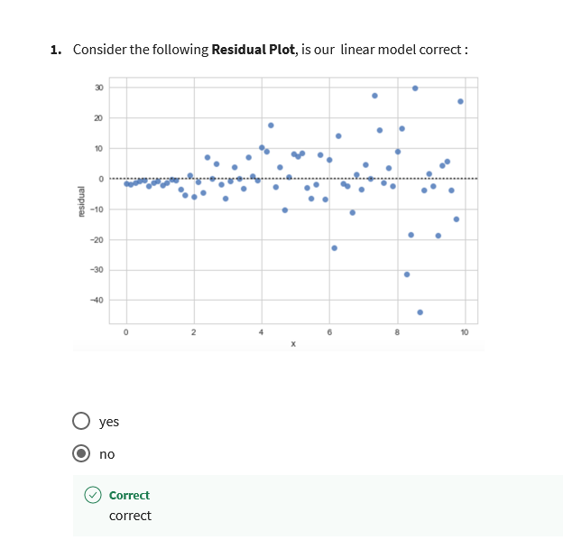

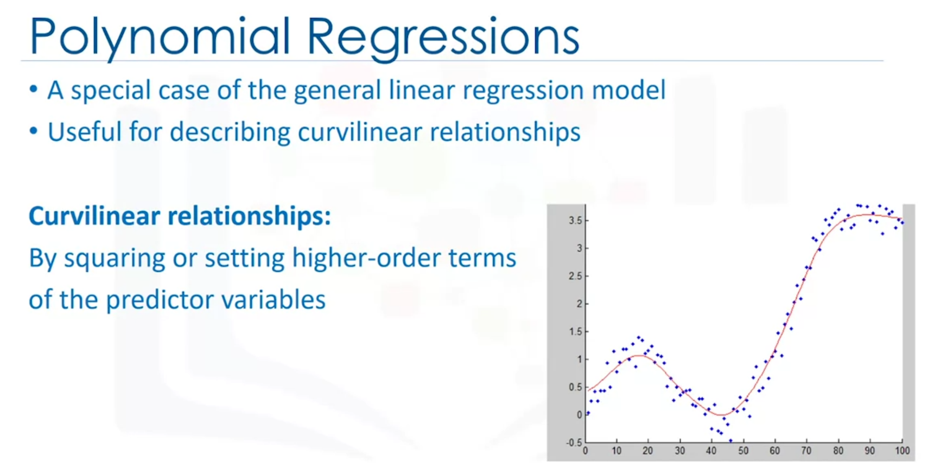

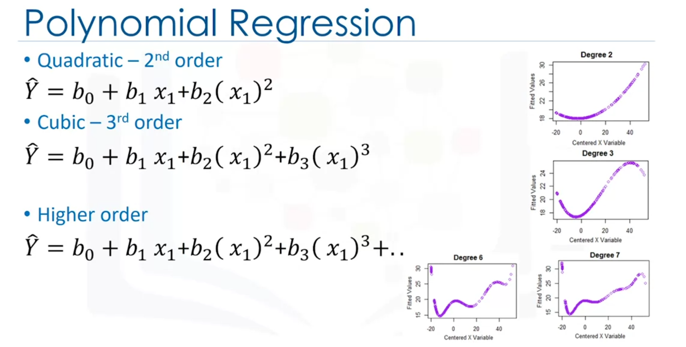

Higher order = better fit can be

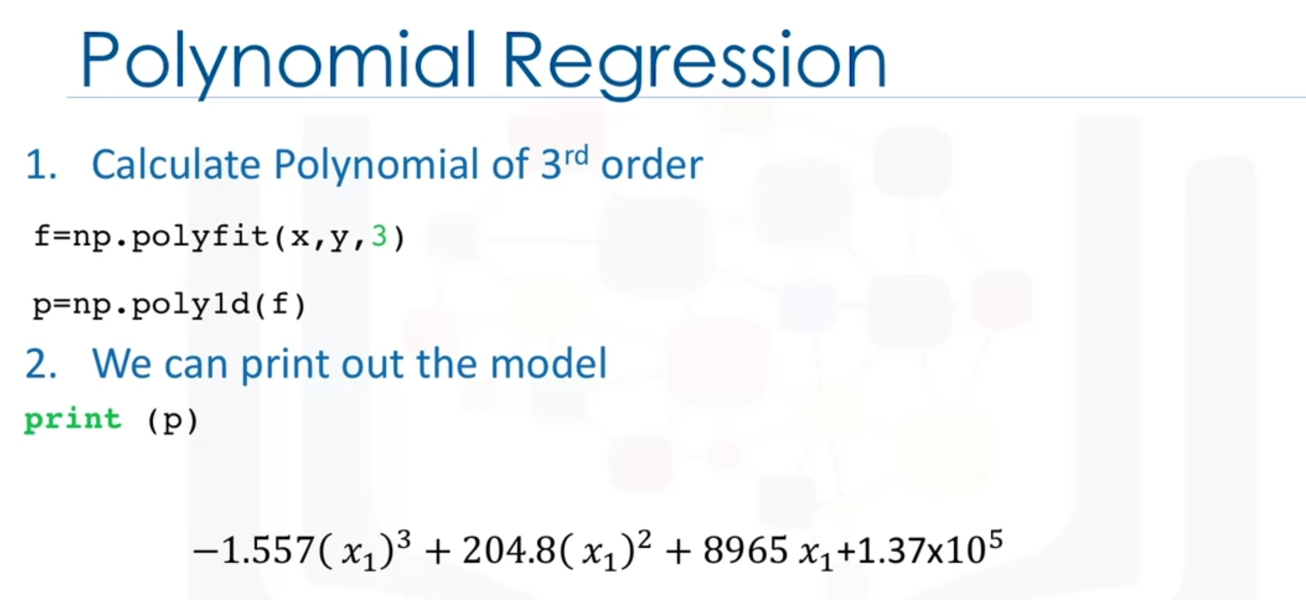





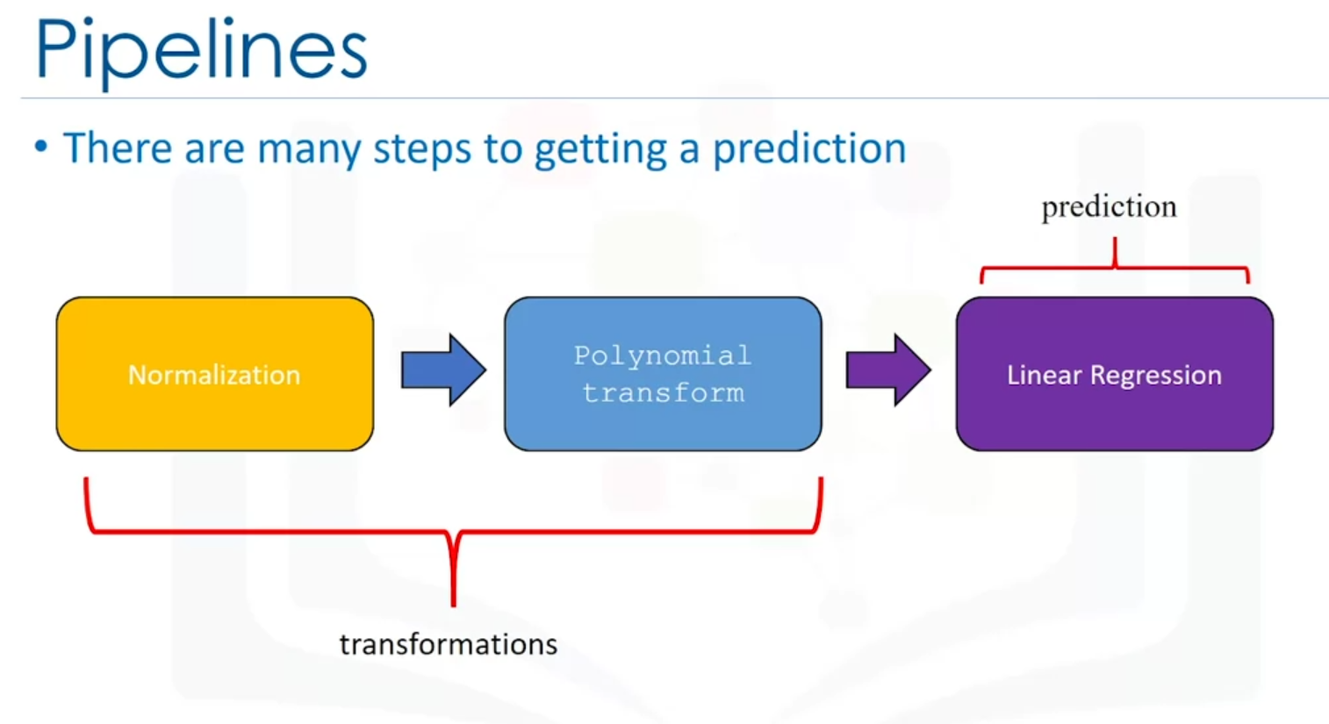

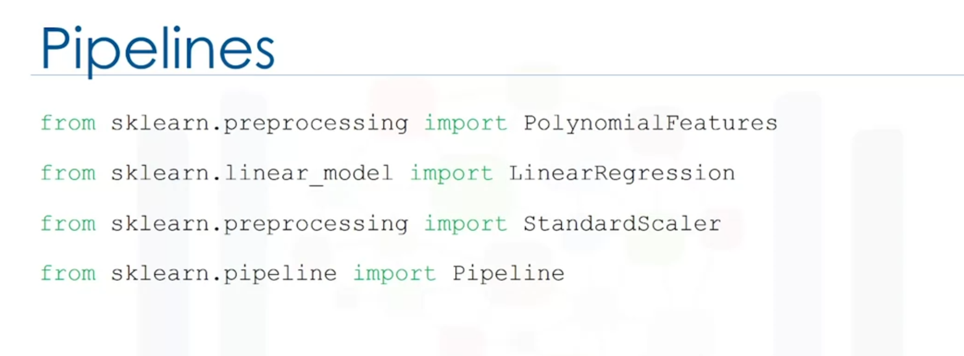

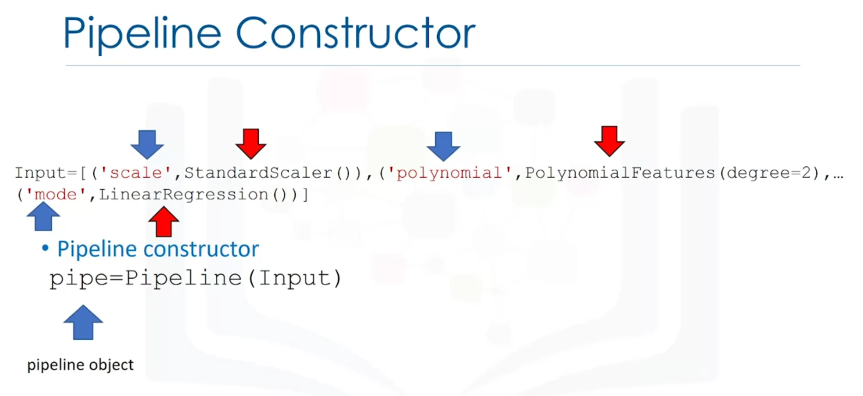

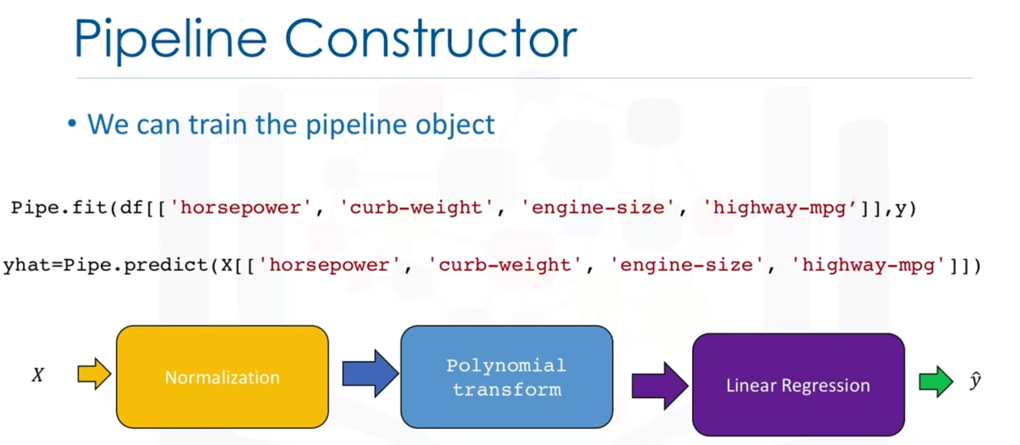

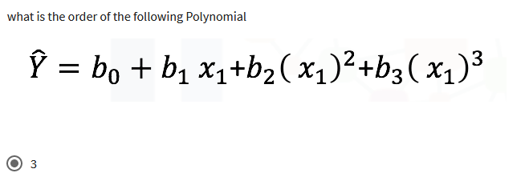

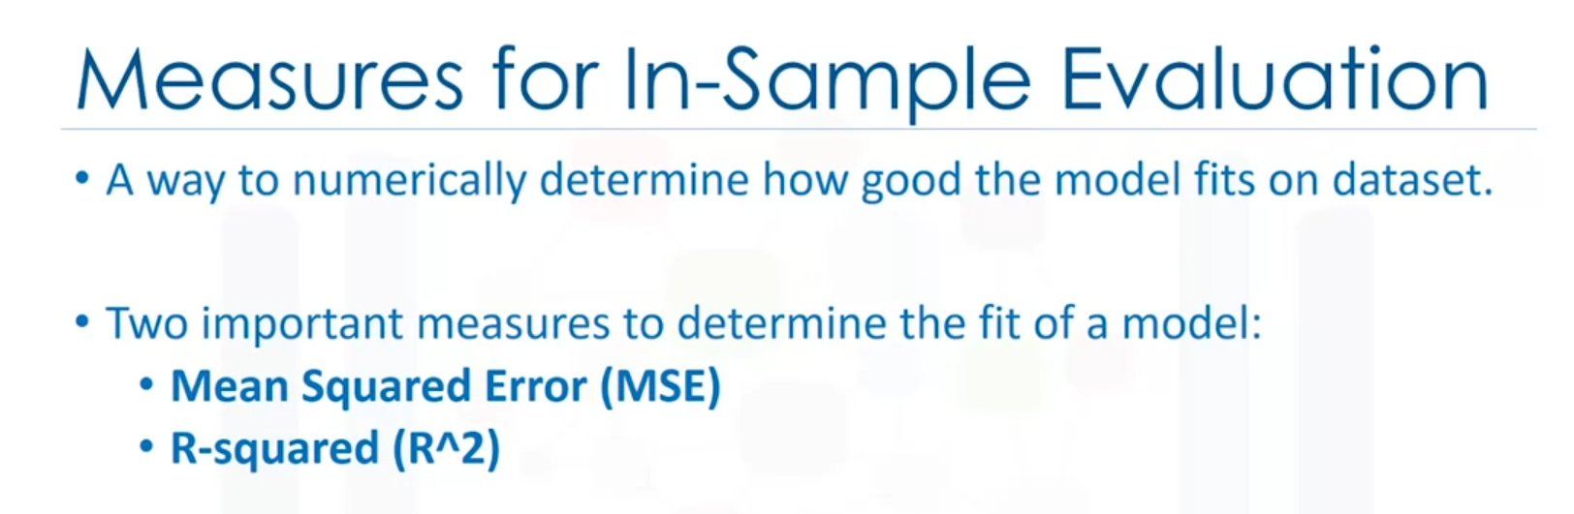

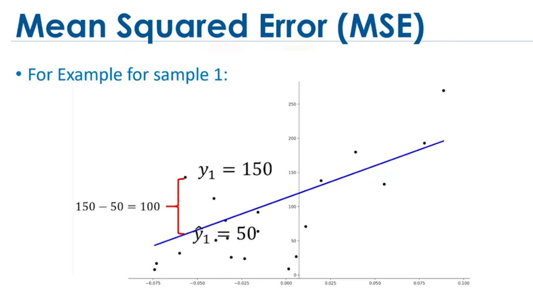

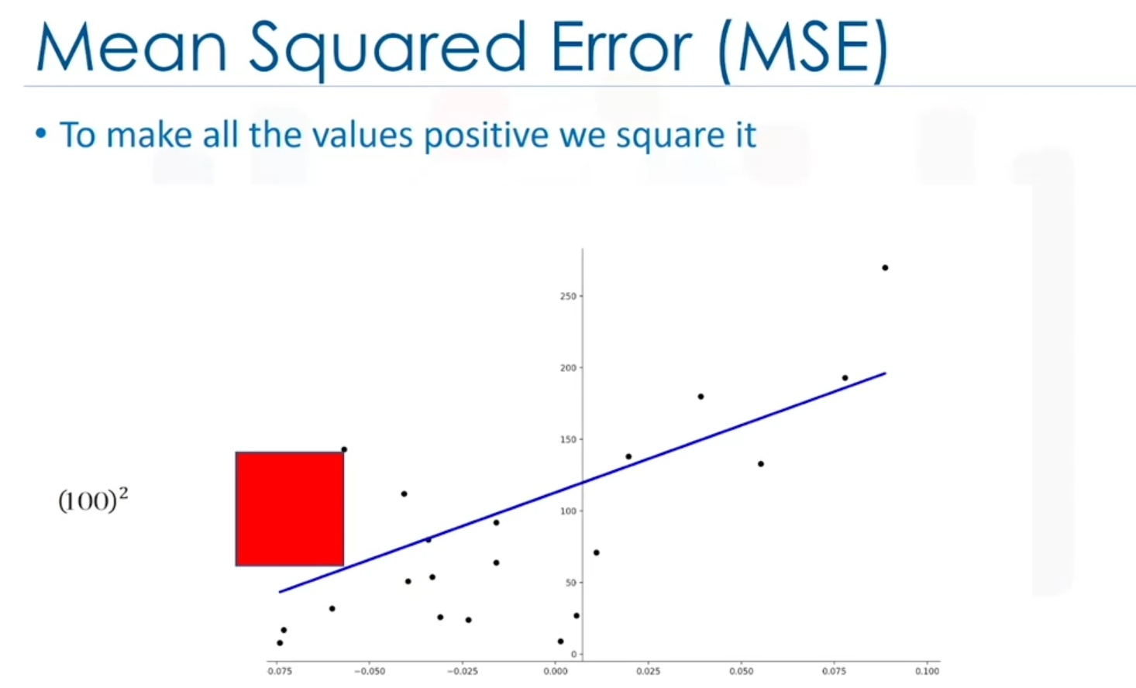

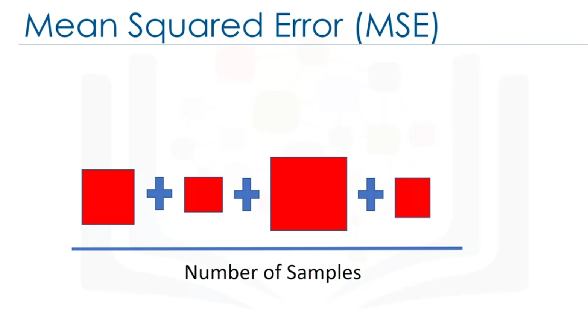

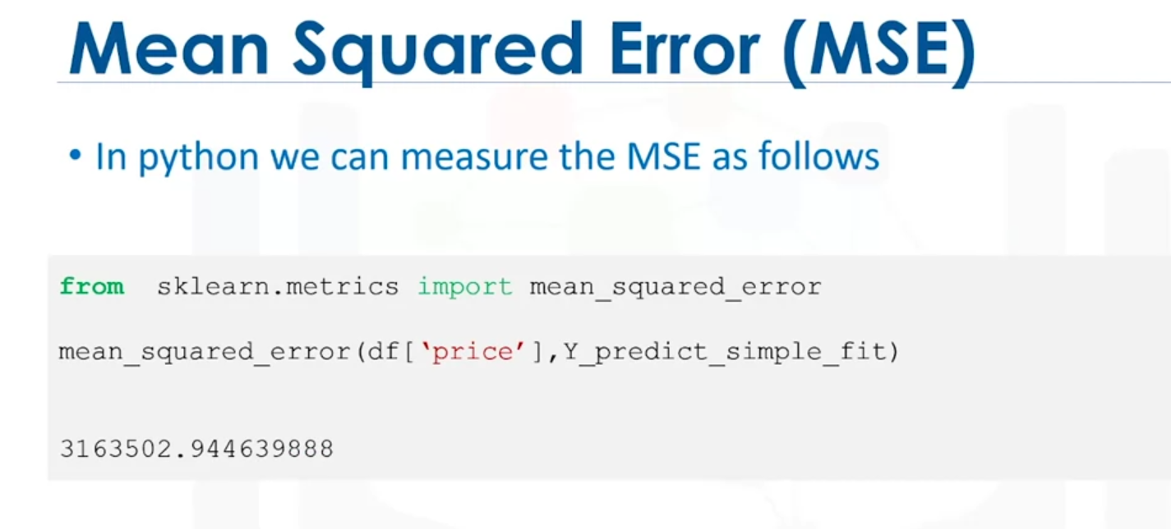

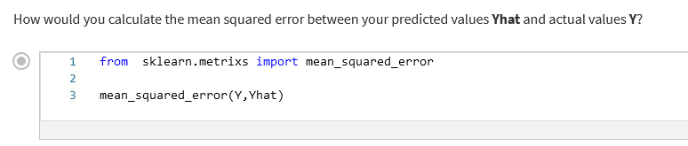

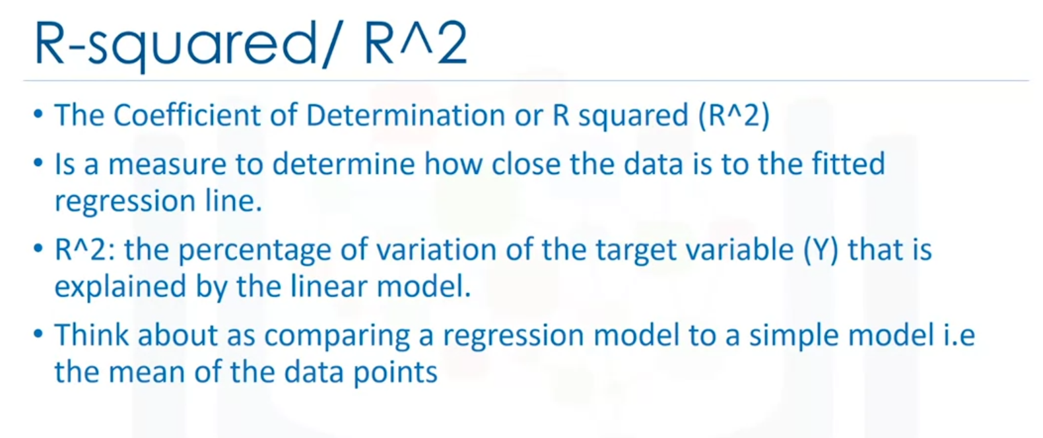



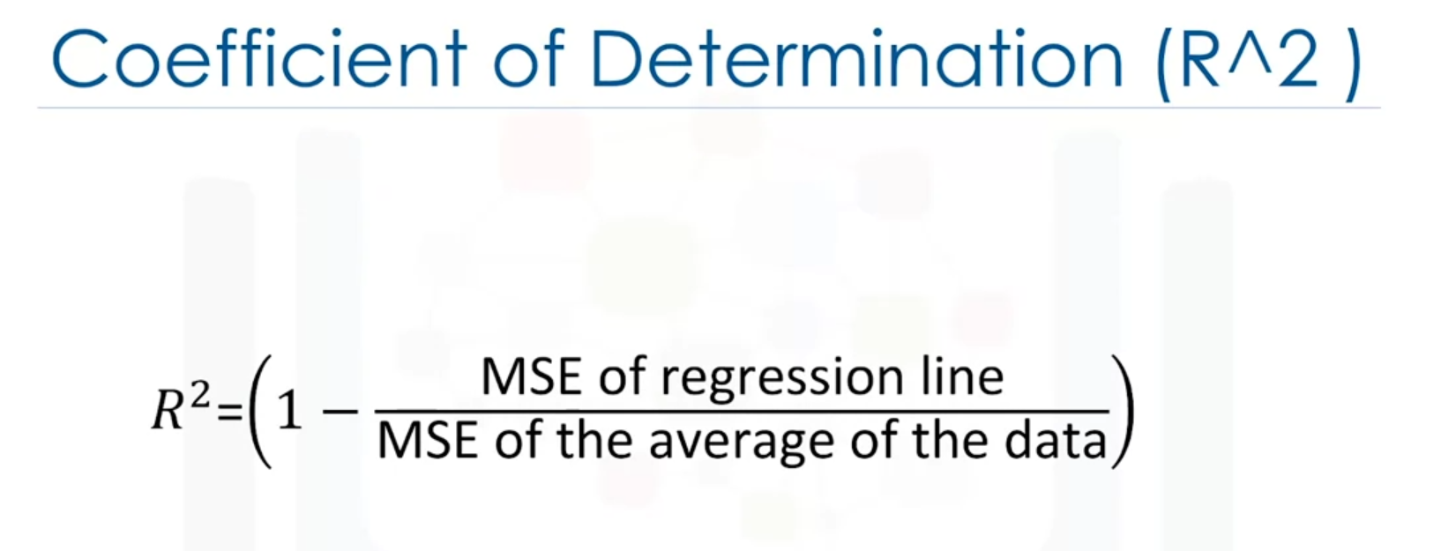

Y bar is the y above.

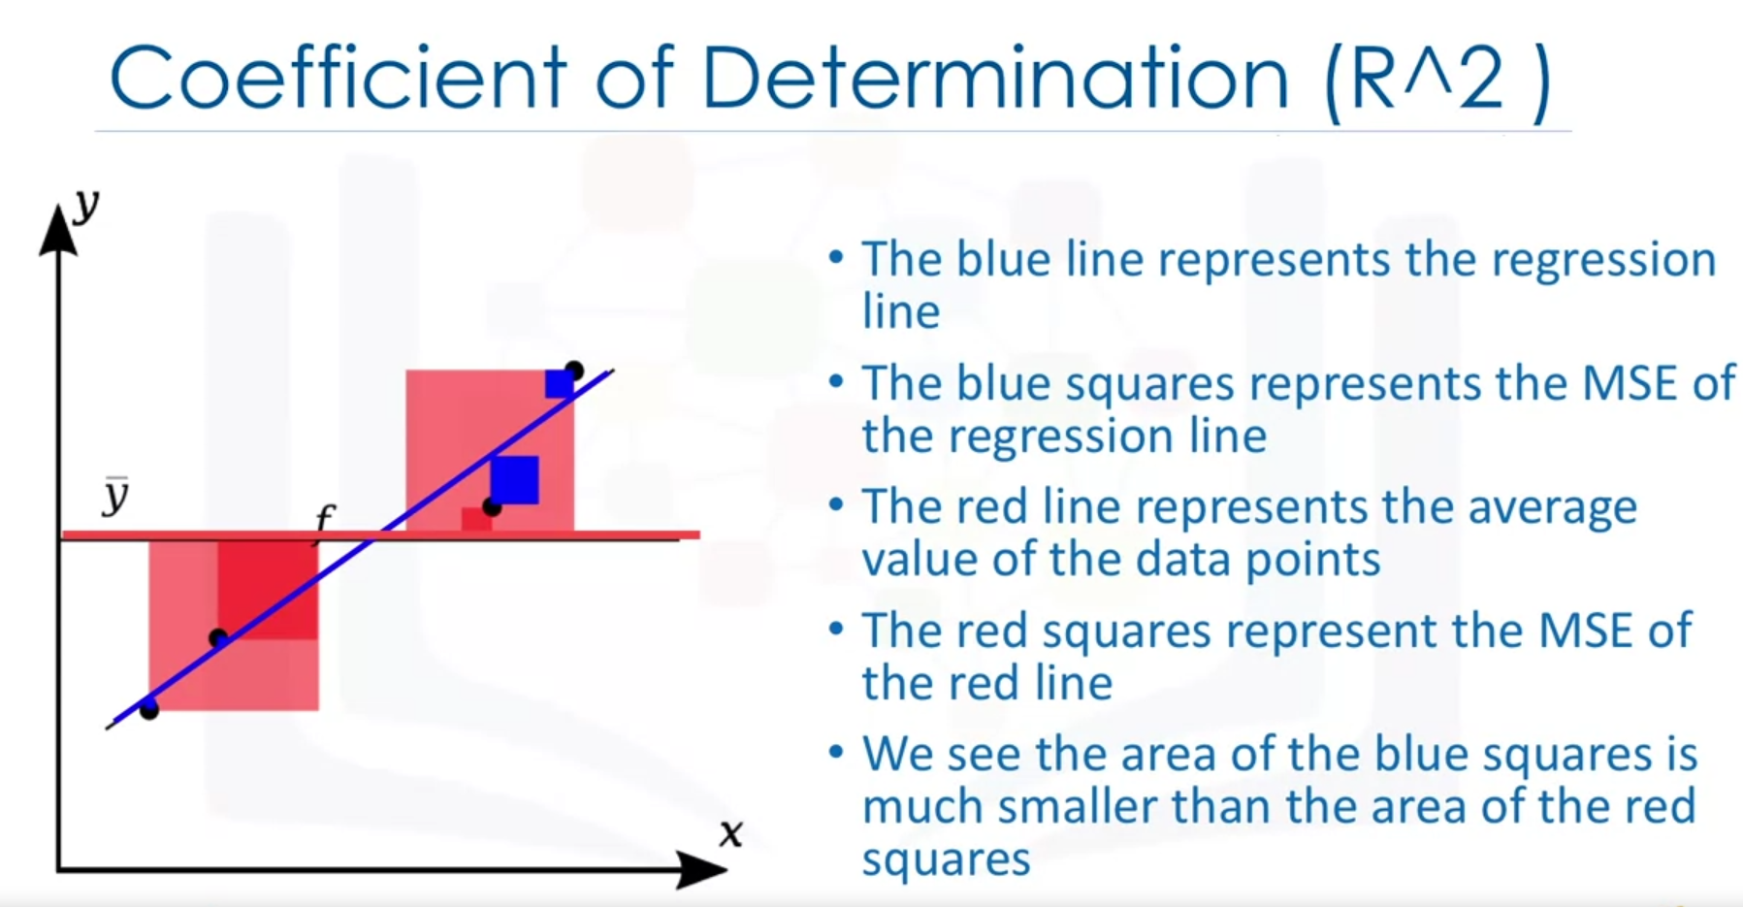

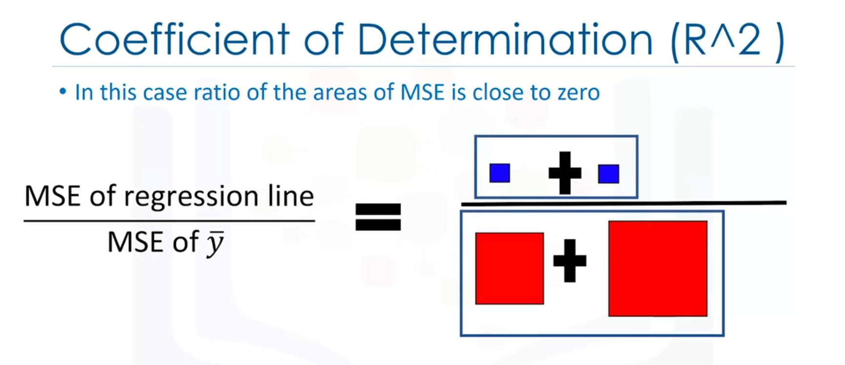

= 0

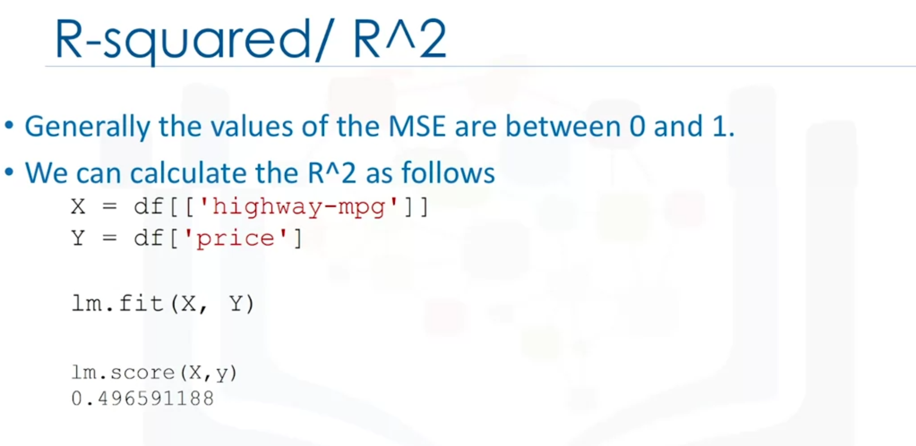

Minimum value of R2 is 0.











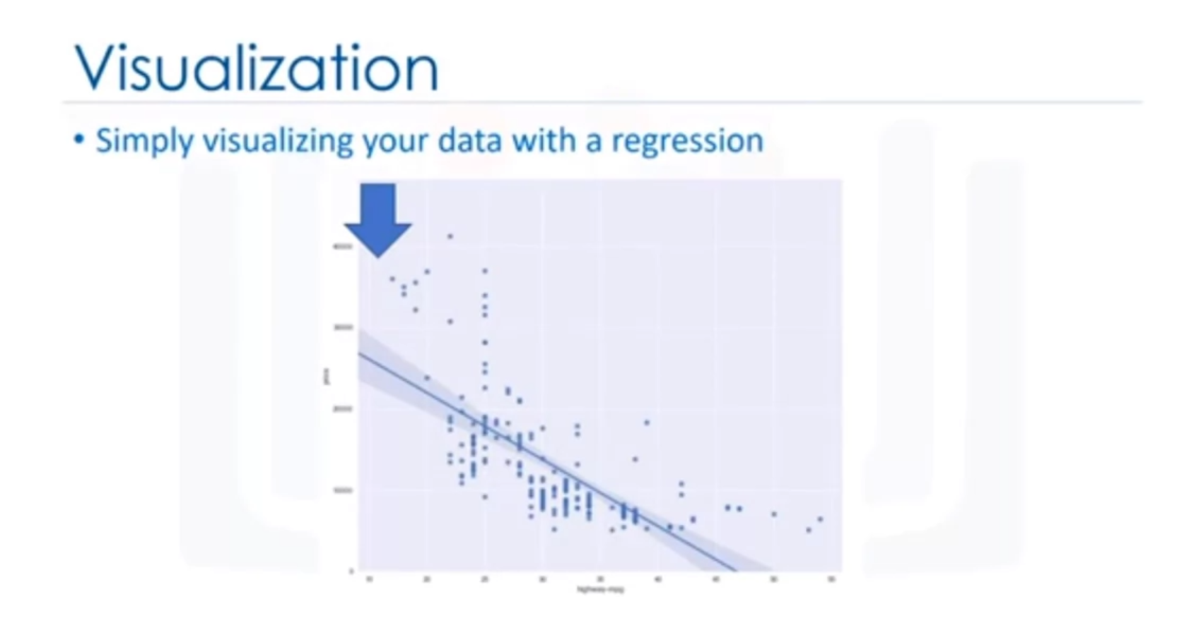

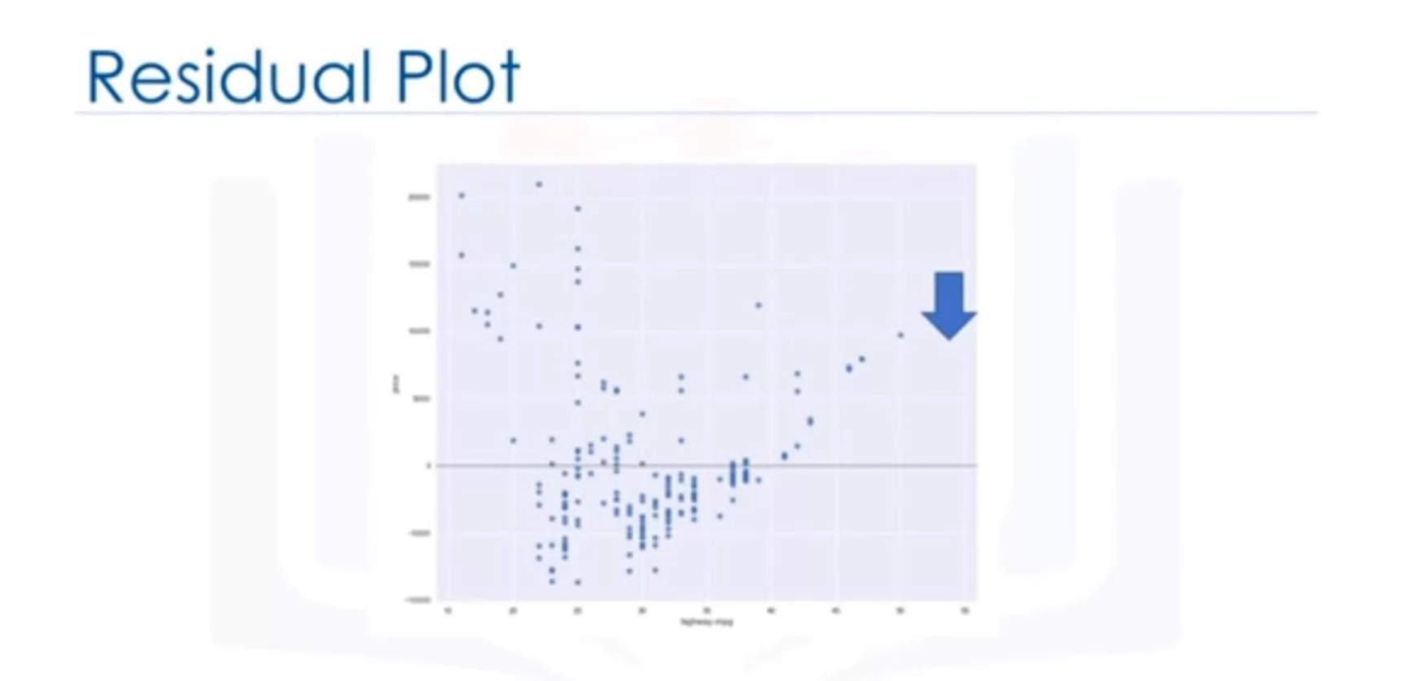

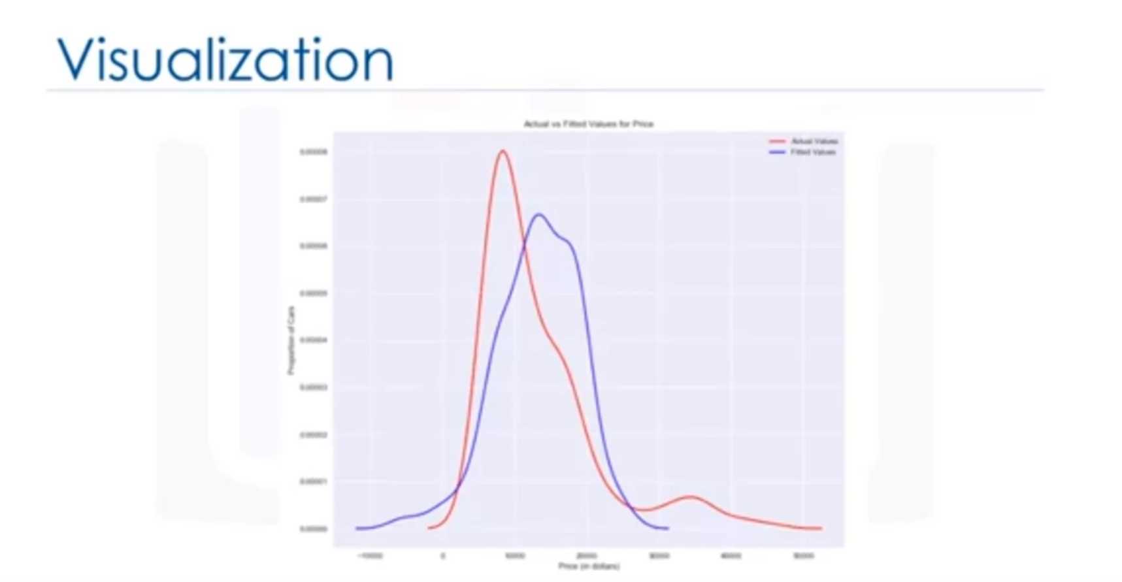



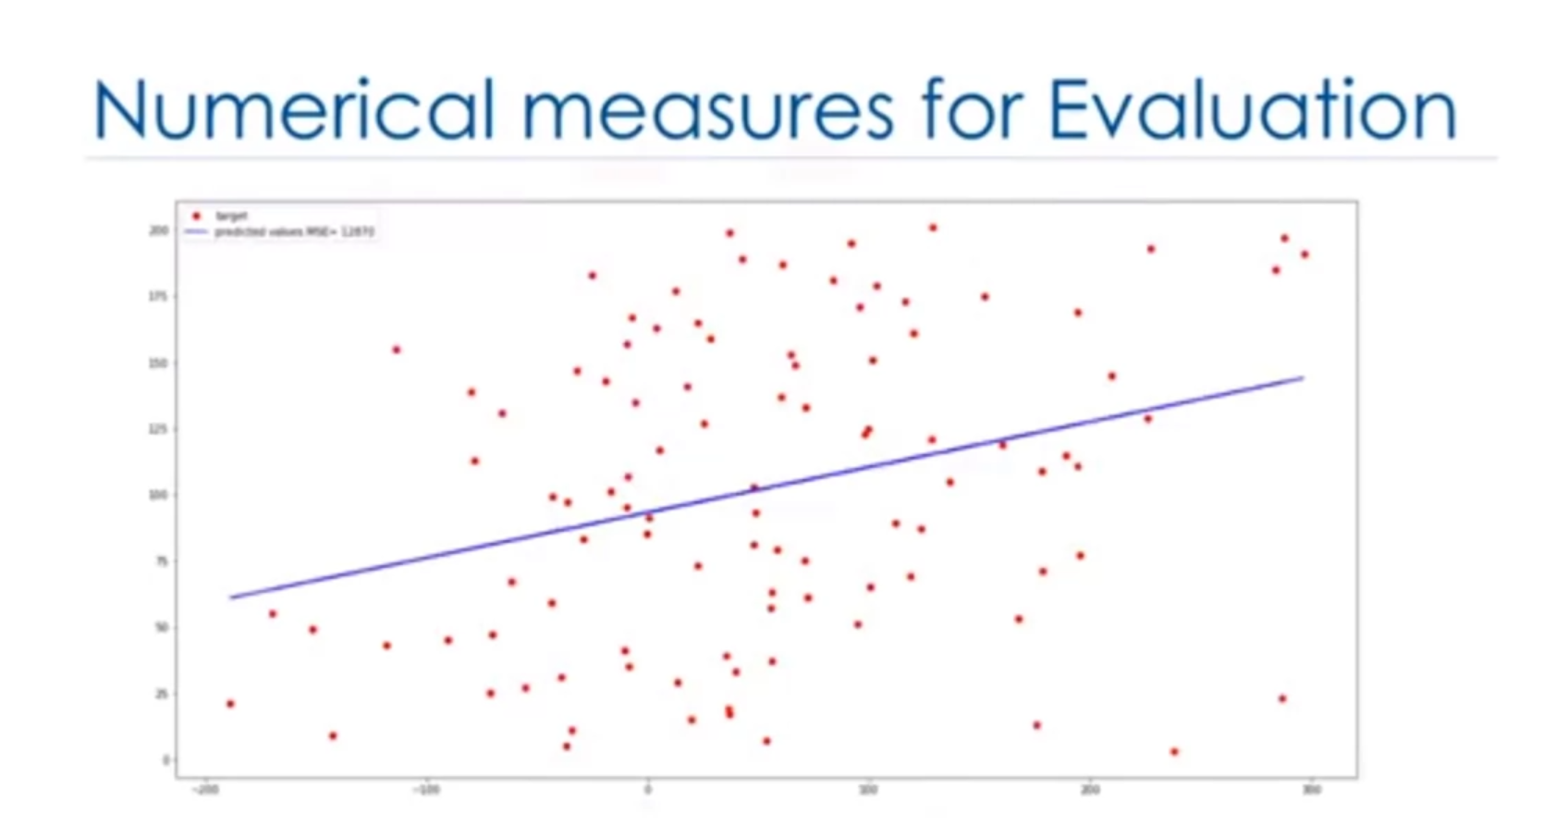

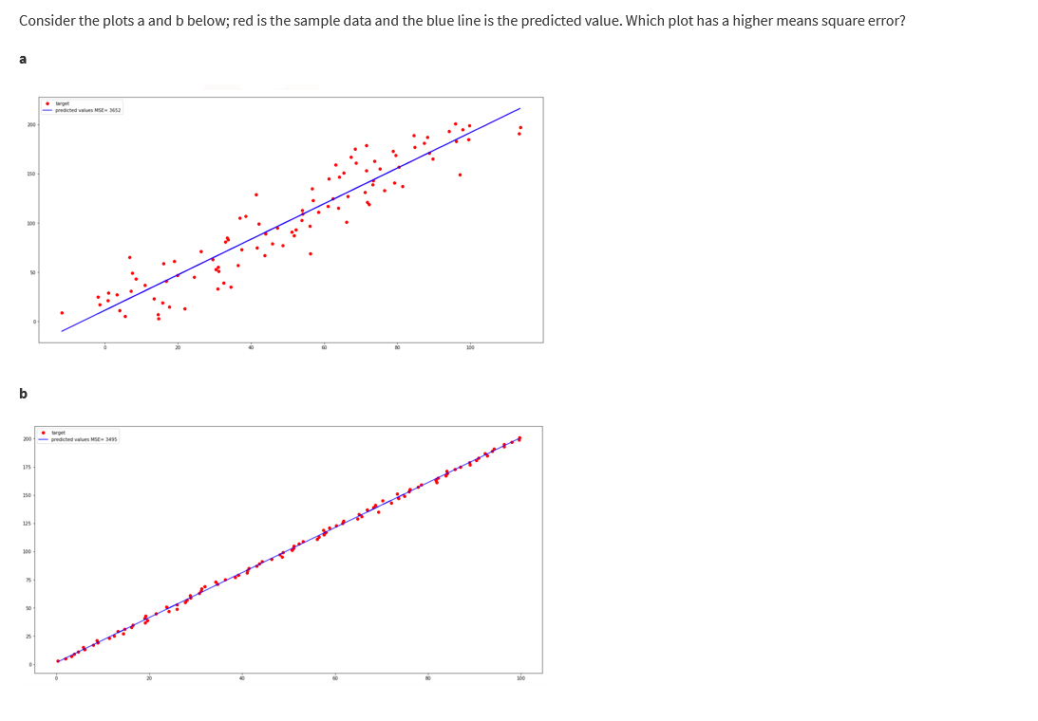

Plot a has a higher MSE.

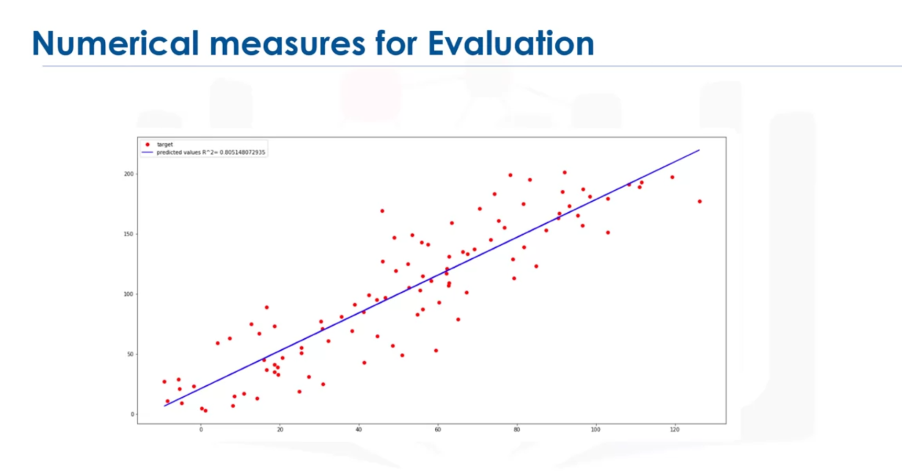

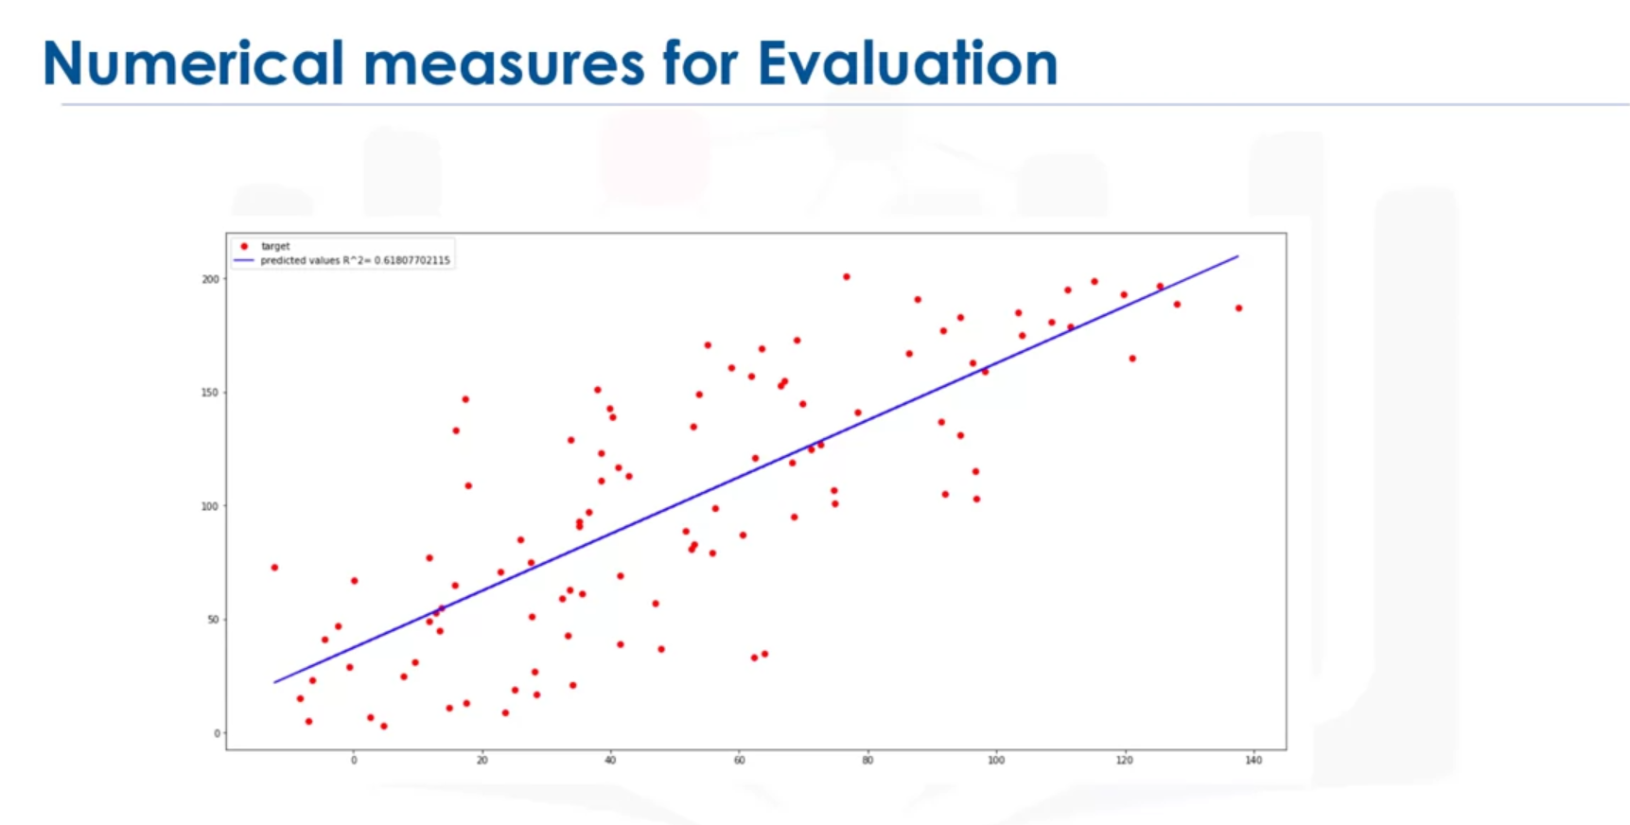60% of the observed variation is due to this value.

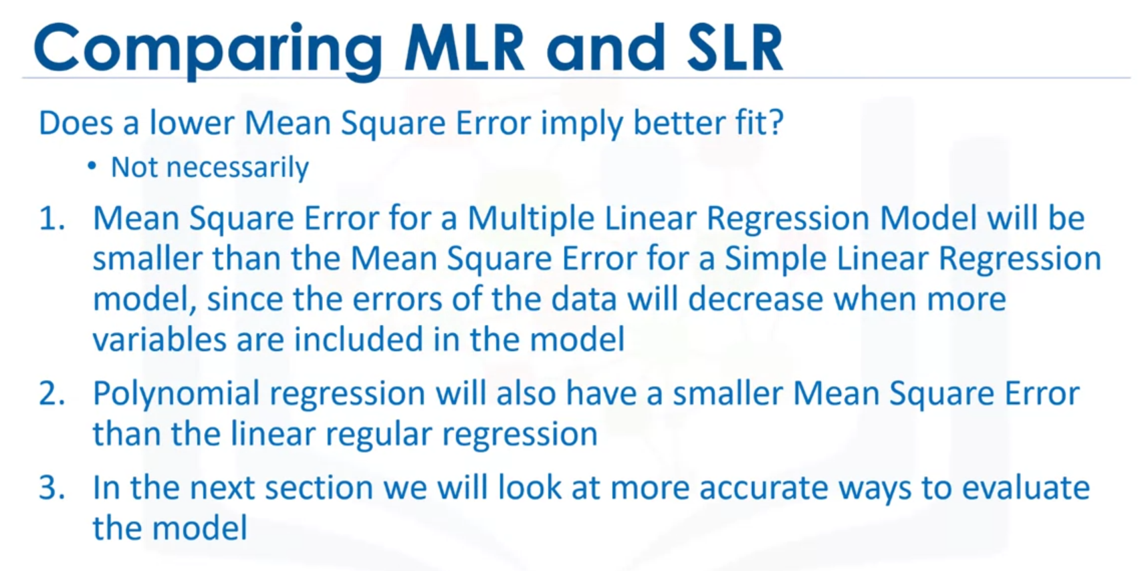

# Lesson Summary

In this lesson, you have learned how to:

**Define the explanatory variable and the response variable:** Define the response variable (y) as the focus of the experiment and the explanatory variable (x) as a variable used to explain the change of the response variable. Understand the differences between Simple Linear Regression because it concerns the study of only one explanatory variable and Multiple Linear Regression because it concerns the study of two or more explanatory variables.

**Evaluate the model using Visualization:** By visually representing the errors of a variable using scatterplots and interpreting the results of the model.

**Identify alternative regression approaches:** Use a Polynomial Regression when the Linear regression does not capture the curvilinear relationship between variables and how to pick the optimal order to use in a model.

**Interpret the R-square and the Mean Square Error:** Interpret R-square (x 100) as the percentage of the variation in the response variable y  that is explained by the variation in explanatory variable(s) x. The Mean Squared Error tells you how close a regression line is to a set of points. It does this by taking the average distances from the actual points to the predicted points and squaring them.

--

In data analytics, we often use **Model Development** to help us predict future observations from the data we have.

A model will help us understand the exact relationship between different variables and how these variables are used to predict the result.

## 1. Linear Regression and Multiple Linear Regression

#### Linear Regression

One example of a Data Model that we will be using is:

**Simple Linear Regression**

Simple Linear Regression is a method to help us understand the relationship between two variables:

* The predictor/independent variable (X)
* The response/dependent variable (that we want to predict)(Y)

The result of Linear Regression is a **linear function** that predicts the response (dependent) variable as a function of the predictor (independent) variable.

*𝑌*:*𝑅𝑒𝑠𝑝𝑜𝑛𝑠𝑒* *𝑉𝑎𝑟𝑖𝑎𝑏𝑙𝑒𝑋*:*𝑃𝑟𝑒𝑑𝑖𝑐𝑡𝑜𝑟* *𝑉𝑎𝑟𝑖𝑎𝑏𝑙𝑒𝑠*

**Linear Function**

*𝑌ℎ𝑎𝑡*=*𝑎*+*𝑏𝑋*

* a refers to the **intercept** of the regression line, in other words: the value of Y when X is 0
* b refers to the **slope** of the regression line, in other words: the value with which Y changes when X increases by 1 unit

#### Multiple Linear Regression

What if we want to predict car price using more than one variable?

If we want to use more variables in our model to predict car price, we can use **Multiple Linear Regression**. Multiple Linear Regression is very similar to Simple Linear Regression, but this method is used to explain the relationship between one continuous response (dependent) variable and **two or more** predictor (independent) variables. Most of the real-world regression models involve multiple predictors. We will illustrate the structure by using four predictor variables, but these results can generalize to any integer:

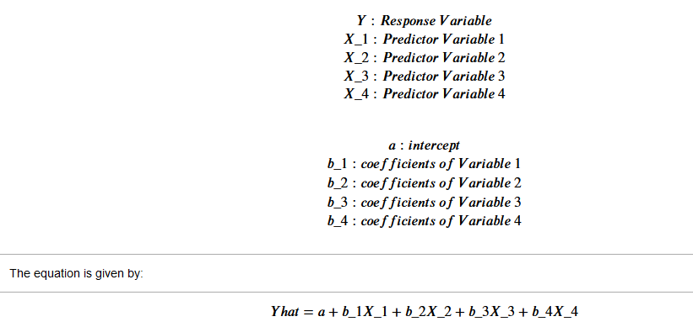

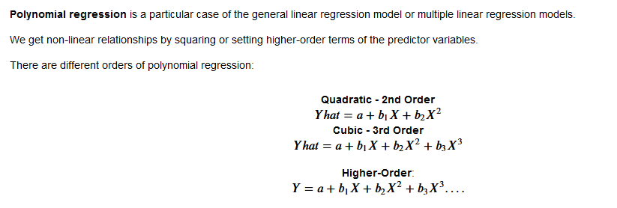

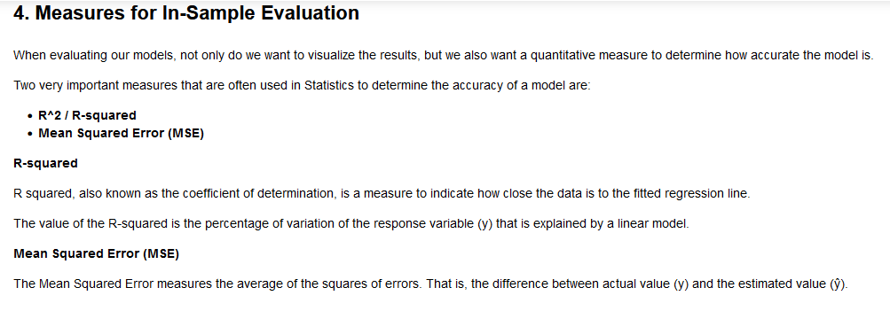

**Decision Making: Determining a Good Model Fit**

Now that we have visualized the different models, and generated the R-squared and MSE values for the fits, how do we determine a good model fit?

* *What is a good R-squared value?*

When comparing models, **the model with the higher R-squared value is a better fit** for the data.

* *What is a good MSE?*

When comparing models, **the model with the smallest MSE value is a better fit** for the data.

#### Let's take a look at the values for the different models.

Simple Linear Regression: Using Highway-mpg as a Predictor Variable of Price.

* R-squared: 0.49659118843391759
* MSE: 3.16 x10^7

Multiple Linear Regression: Using Horsepower, Curb-weight, Engine-size, and Highway-mpg as Predictor Variables of Price.

* R-squared: 0.80896354913783497
* MSE: 1.2 x10^7

Polynomial Fit: Using Highway-mpg as a Predictor Variable of Price.

* R-squared: 0.6741946663906514
* MSE: 2.05 x 10^7

### Simple Linear Regression Model (SLR) vs Multiple Linear Regression Model (MLR)

Usually, the more variables you have, the better your model is at predicting, but this is not always true. Sometimes you may not have enough data, you may run into numerical problems, or many of the variables may not be useful and even act as noise. As a result, you should always check the MSE and R^2.

In order to compare the results of the MLR vs SLR models, we look at a combination of both the R-squared and MSE to make the best conclusion about the fit of the model.

* **MSE**: The MSE of SLR is 3.16x10^7 while MLR has an MSE of 1.2 x10^7. The MSE of MLR is much smaller.
* **R-squared**: In this case, we can also see that there is a big difference between the R-squared of the SLR and the R-squared of the MLR. The R-squared for the SLR (~0.497) is very small compared to the R-squared for the MLR (~0.809).

This R-squared in combination with the MSE show that MLR seems like the better model fit in this case compared to SLR.

### Simple Linear Model (SLR) vs. Polynomial Fit

* **MSE**: We can see that Polynomial Fit brought down the MSE, since this MSE is smaller than the one from the SLR.
* **R-squared**: The R-squared for the Polynomial Fit is larger than the R-squared for the SLR, so the Polynomial Fit also brought up the R-squared quite a bit.

Since the Polynomial Fit resulted in a lower MSE and a higher R-squared, we can conclude that this was a better fit model than the simple linear regression for predicting "price" with "highway-mpg" as a predictor variable.

### Multiple Linear Regression (MLR) vs. Polynomial Fit

* **MSE**: The MSE for the MLR is smaller than the MSE for the Polynomial Fit.
* **R-squared**: The R-squared for the MLR is also much larger than for the Polynomial Fit.

## Conclusion

Comparing these three models, we conclude that **the MLR model is the best model** to be able to predict price from our dataset. This result makes sense since we have 27 variables in total and we know that more than one of those variables are potential predictors of the final car price.